An **un-equi join** in SQL involves joining tables using a condition other than equality (e.g., >, <, >=, <=, !=). Here's an example for an un-equi join with hypothetical scenarios involving Student and Course.

**Scenario:**

Suppose you have the following rule:

* Assign courses based on a student's **age range**, rather than a direct match of CourseID.

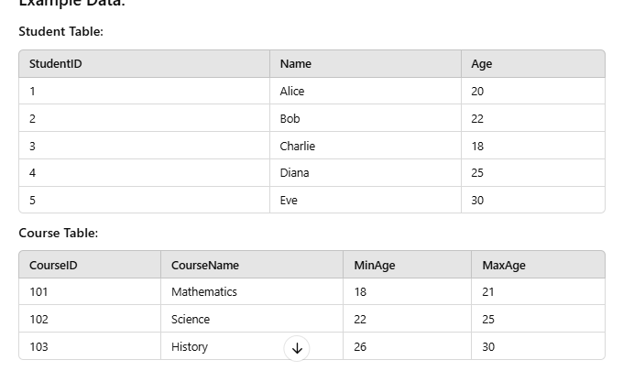

SELECT Student.StudentID, Student.Name, Student.Age,

Course.CourseID, Course.CourseName FROM

Student JOIN Course ON Student.Age BETWEEN Course.MinAge AND Course.MaxAge;